 

WORKSHEET – 2.3

**Name:-**Rahul Maurya UID:- 20BCS7260

Class/section :- 716B Subject :- CN Lab

# Aim:

Understand Routing Mechanism.

# Task to be done:

Create a network to implement Distance Vector routing Protocol using Packet Tracer.

# Requirements:

Packet Tracer.

# Result/Output/Writing Summary:

## Static Routing:

Static routing is the manual method of routing . In static routes the administrative distance is as default value. In **Static routing**, we can enter all the routes manually to the router. In other words, we can define each routing steps **one by one**. To access a network, which nodes we need to pass through, we can define such steps. This work is not an easy work, so static routing is used in small networks.

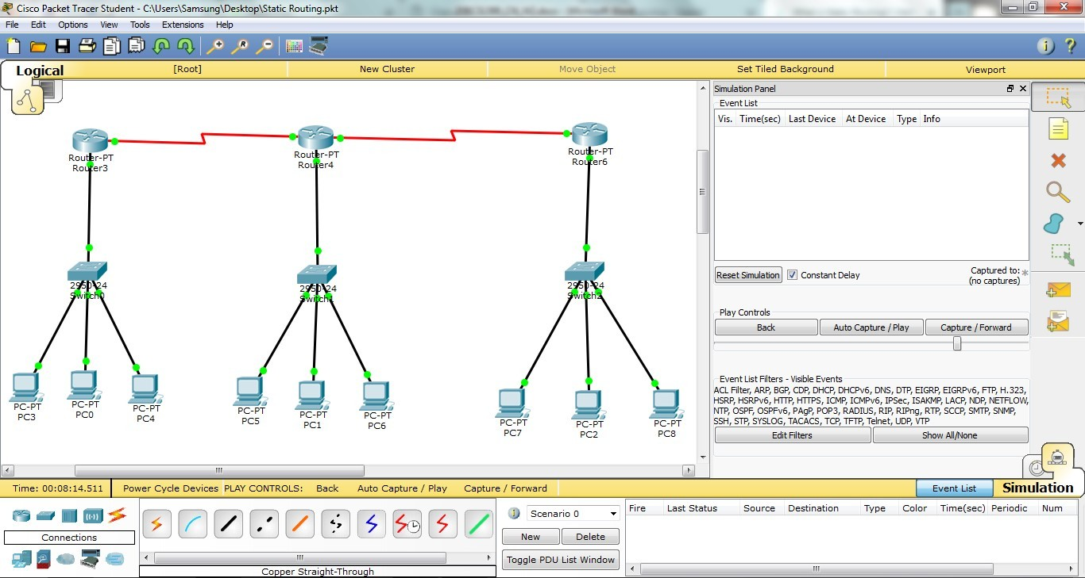

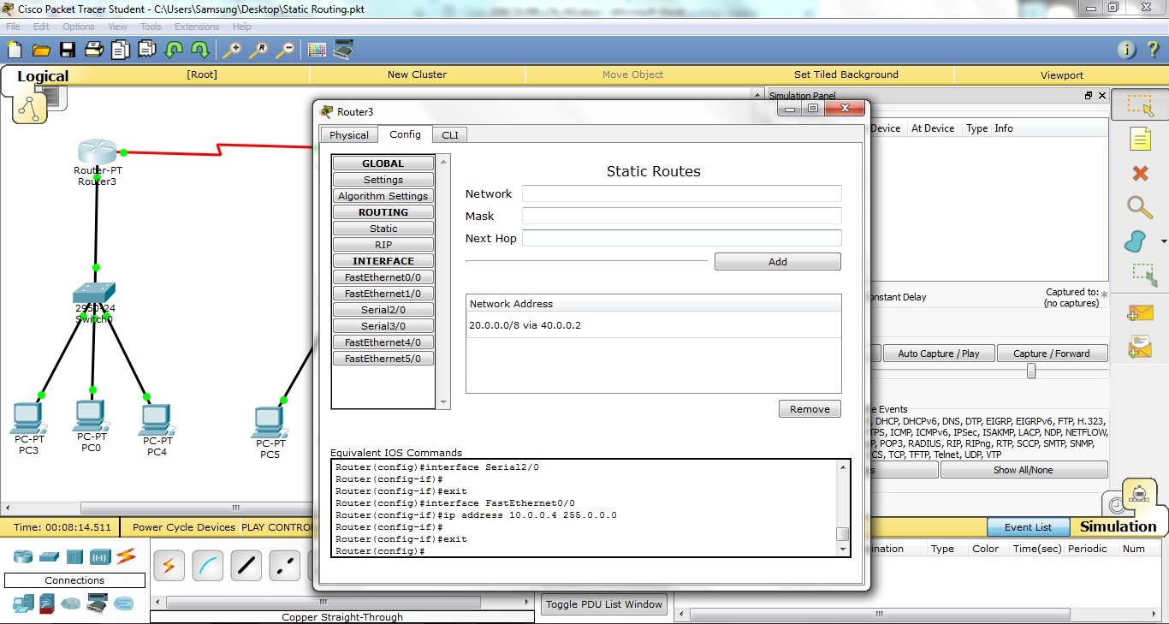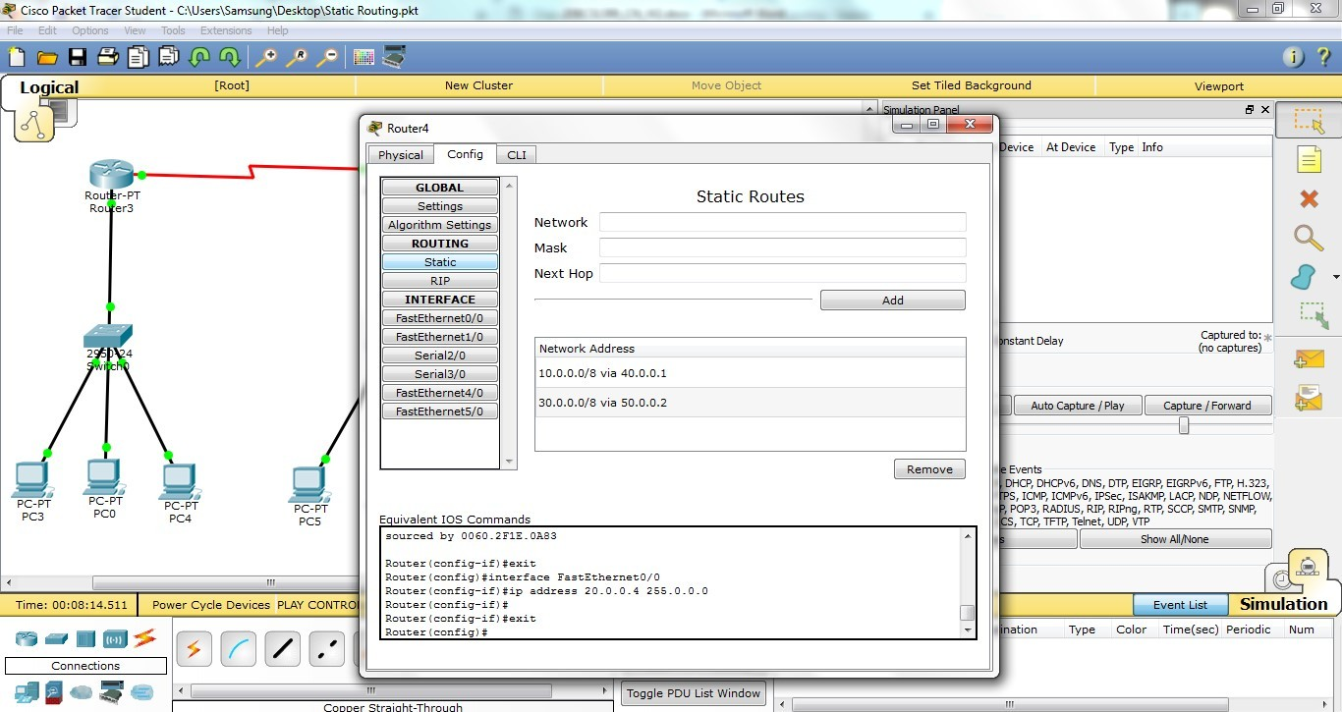**CHANDIGARH UNIVERSITY COMPUTER NETWORKS LAB**

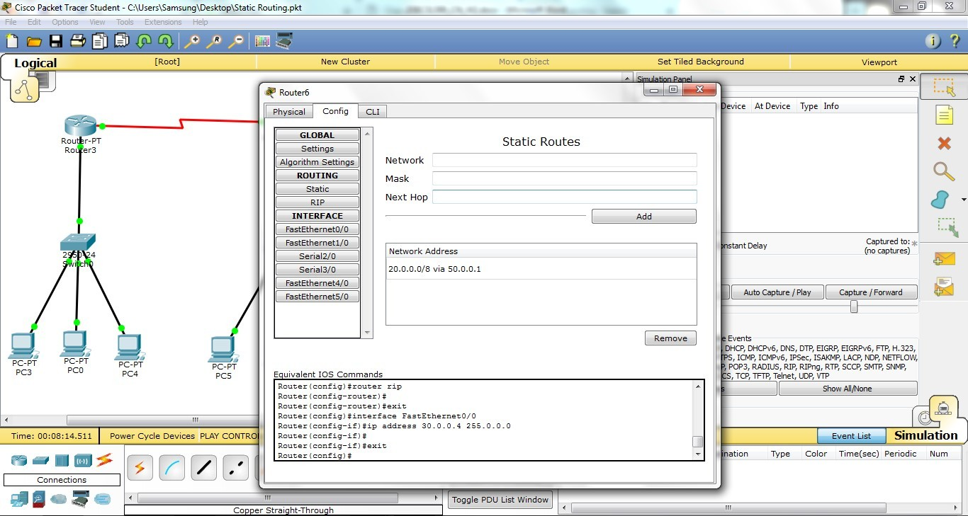

## Dynamic Routing:

Dynamic routing is the routing that is done with the help of Routing Protocols. Dynamic Routing is a network routing procedure that facilitates the

routers to pick and choose the routing paths depending on the network structure’s logical changes in real-time. This is opposite to the typical traditional static network routing. This is an automated routing technique that requires very less administration and supervision. Various protocols used in this routing method are Open Shortest Path First (OSPF), Routing Information Protocol (RIP), Border Gateway Protocol (BGP), and Enhanced Interior Gateway Routing Protocol (EIGRP).

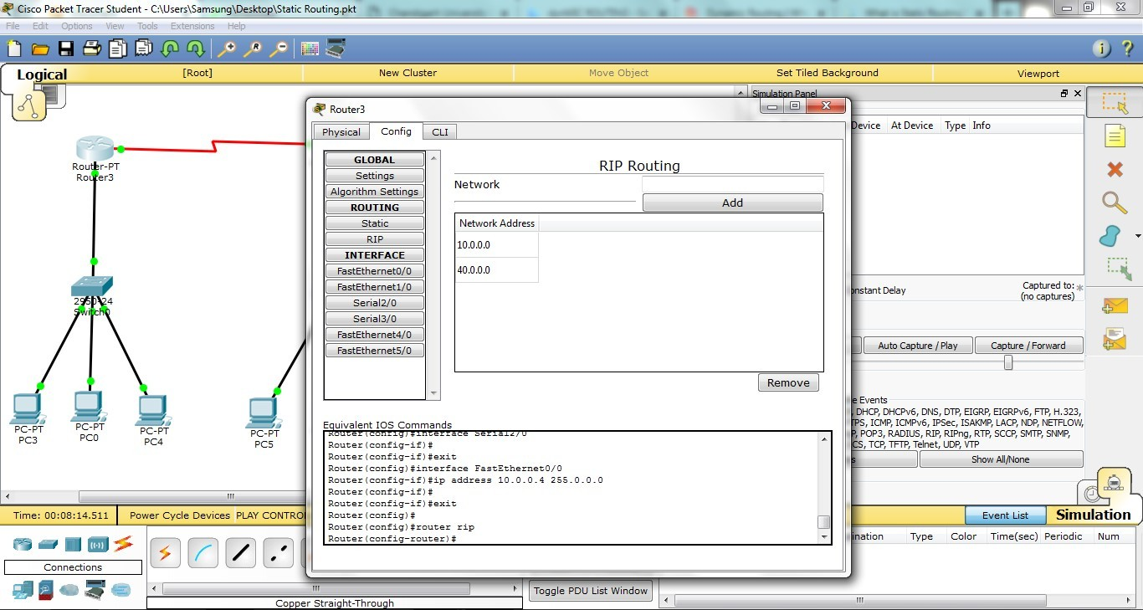

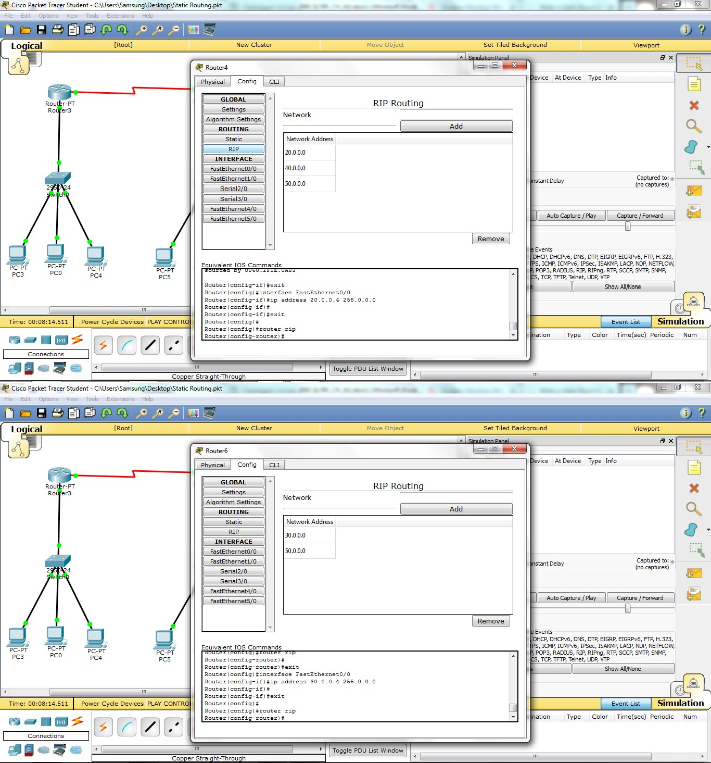

**CHANDIGARH UNIVERSITY COMPUTER NETWORKS LAB**

 

Complete Network:

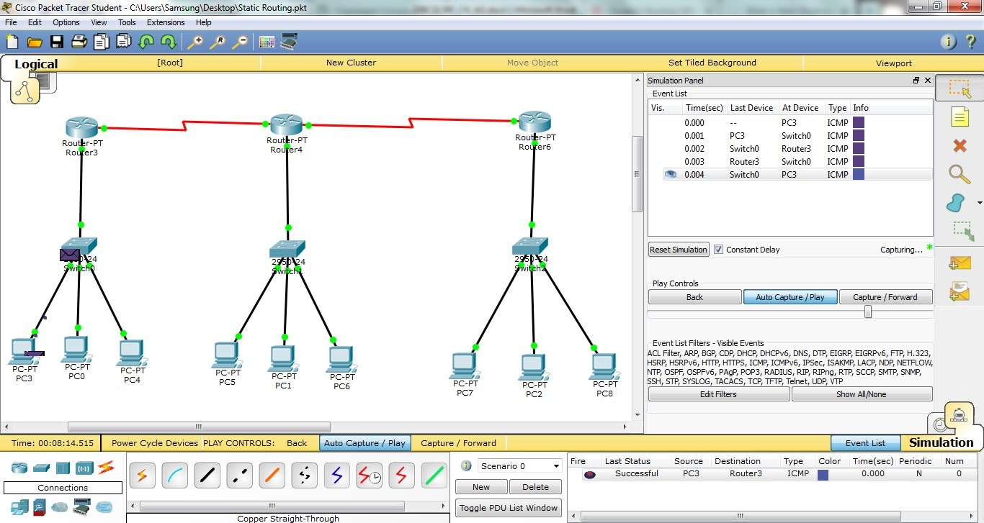

(Message Sent from Pc3 to router-3)

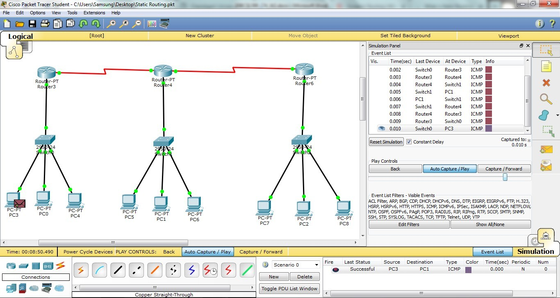

(Message sent from Pc-3 to Pc-1)

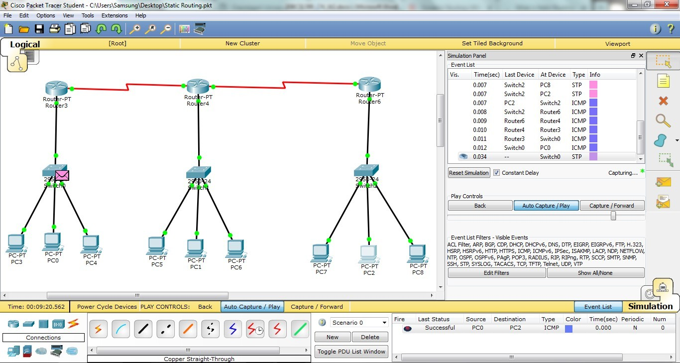

(Message Sent from PC-0 to Pc-2)

**CHANDIGARH UNIVERSITY COMPUTER NETWORKS LAB**

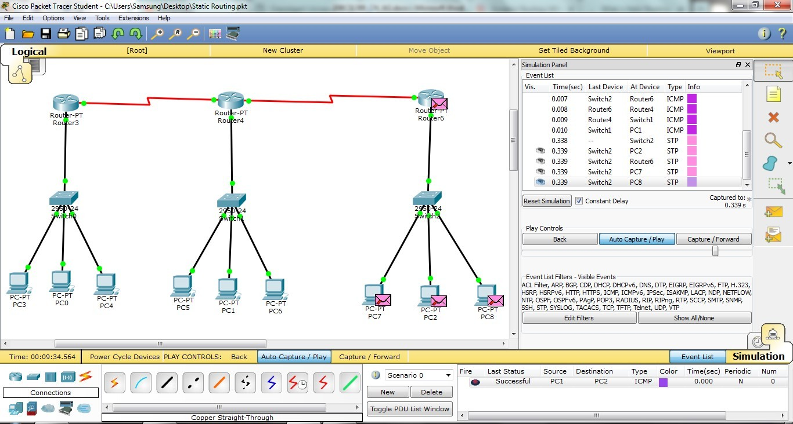

(Message sent from Pc-1 to Pc-2)

## Learning outcomes (What I have learnt):

* Leant about Routing.
* Learnt how to configure network using static and dynamic routing.
* How to troubleshoot the network.
* Learnt to route the different networks.

## Evaluation Grid (To be created as per the SOP and Assessment guidelines by the faculty):

|  |  |  |  |
| --- | --- | --- | --- |
| Sr.  No. | Parameters | Marks Obtained | Maximum Marks |
| 1. |  |  |  |
| 2. |  |  |  |
| 3. |  |  |  |

**CHANDIGARH UNIVERSITY COMPUTER NETWORKS LAB**